Arduino Lesson 1
Hello World！
- Intro
Let Arduino say “Hello World!” only with Arduino and USB download cable as below.This experiment allows Arduino to communicate with computer.
- Parts required：
Arduino main board 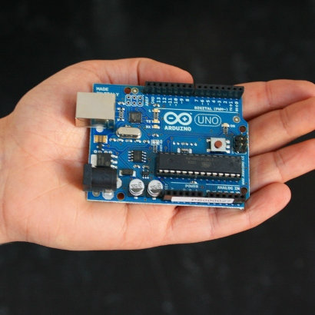
USB download cable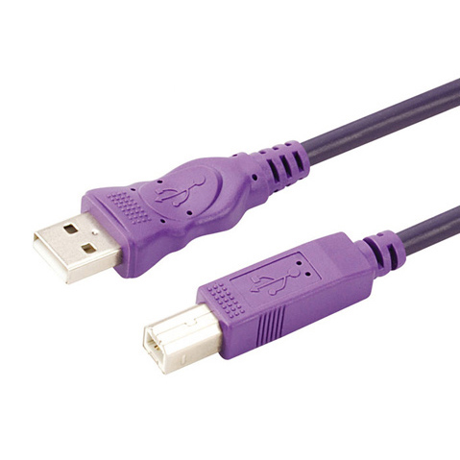

Start Arduino (download at: http://arduino.cc/en/Main/Software) after arduino driver installed. Program to make Arduino accept order say “Hello World！”，and you could make it work by simply using “if（）”.Use the “L” led on Arduino to make a blink then display “Hello World！”
- Program for reference.
int val;//Define variable val
int ledpin=13;//Define digital interface 13
void setup()
{
Serial.begin(9600);// Setup Baud Rate as 9600，same as the software setup。When access specific device (such as bluetooth), make sure the baud rate setup consistently.
pinMode(ledpin,OUTPUT);//Setup digital interface Interface13 as output，Arduino all the I/O interface used on Arduino have to be defined like this.
}
void loop()
{
val=Serial.read();//Read the command or characters from PC to Arduino,and assign to val
if(val=='R')//Determine if the command or characters is “R”
{//If receive “R”
digitalWrite(ledpin,HIGH);//Turn on LED on digital interface 13.
delay(500);
digitalWrite(ledpin,LOW);//Turn off LED on digital interface 13.
delay(500);
Serial.println("Hello World!");//Display“Hello World！”characters.
}
}